

COMPUTER SCIENCE DEPARTMENT

ONLINE AUCTION SYSTEM

Done by:

1 Lulit Fiseha

2 Getahun Ababu

3 Tarekegn Tadele

4 Yabsra Bogale

DATE

SMU

ADDIS ABABA

Advisor : Rediet Ashinie

**Chapter 1: Introduction**

* 1. Background of the Organization
  2. Statement of the Problem and Justification
  3. Objective of the Project
     1. General Objective
     2. Specific Objective (s)
  4. Methodologies
  5. Tools
  6. Scope and Limitation
  7. Significance of the Project
  8. Feasibility Study
  9. Risk Assessment
  10. Work Break Down

**Chapter 2: Requirement Analysis and Specification**

* 1. Current system
  2. Business rules
  3. Proposed system
     1. Overview
     2. Functional requirements
     3. Nonfunctional requirements
     4. System models
        1. Use case model
        2. Sequence diagram
        3. State chart diagram
        4. Activity diagram
        5. Class diagram
        6. User interface prototyping

**Chapter 3: System Design**

* 1. Introduction
  2. Purpose of the system
  3. Design goals
  4. Current software architecture
  5. Proposed software architecture
     1. Subsystem decomposition
     2. Component diagram
     3. Deployment diagram
     4. Persistent data management
     5. Access control and security
     6. Global software control
     7. Boundary conditions

### Introduction

The online auction system is a web application where all products are displayed in different categories and a customer can bid to the selected category wised product without facing any problem. The online auction system deals between sellers and bidders. It provides the users for sign up to this application and search for products, manages their accounts.

Electronic commerce, also known as e-commerce, has developed rapidly in recent years. More and more and more consumers prefer to shop online for convenience and other benefits. E-commerce and auctions are also attracting attention. Many internet companies like eBay and Yahoo have launched their own auction platforms. Consumer to consumer (C2C) is a business model whereby customers can trade with each other. The consumer to consumer auction is usually an online environment where one customer purchases good from another customer using a third-party platform to facilitate the auction process. The global reach of online auction market allows for the buyers and sellers to overcome geographical constraints and purchase products anytime from anywhere over the internet. Online auction systems provide a more convenient platform for purchasing products than a traditional market. It provides the consumers with great advantages of low prices, greater product selection and greater efficiency compared to the usual traditional offline markets. The reputation of online auctions may be attributed to the simplicity in price negotiations - certainly considered the most frustrating part of the interaction between buyers and sellers. It provides a flexible price point for products unlike the traditional online stores or physical stores. The functional and operational characteristics of the online auctions are different from those of other e-commerce companies.

**1.1 Background of Organization**

For our project we consider the online auction system as our target. In our country there is not much of auction site. So this is a modified and improved idea for ethiopia. This web based application helps users to choose their desire products and upload products on the site. Users can also easily bid on particular products. This provides a great alternative of auction system for general people.

**1.2 Statement of Problem**

The problem which usually arises in the traditional method of auctioning is that the participants would have to leave their various homes to auctions, this cannot be easy at times and also there are risks involves, for example, a participant may be a victim of a targeted armed robbery attack after bidding . Another issue is the amount of preparation needed before each auction, combined with the high cost of setting up the auction, which made the traditional method efficient for only for the auction of expensive items. With internet, most of these issues have been resolved but there are still a few issues with the existing online auction systems. The major problem with online auctions is inability of buyers to properly and physically evaluate the product quality as the whole process happens over the internet this greatly affects a buyer’s choice when it comes to partaking in online auctions. These problems discourages users from participating in online auctions and hurts the online auction industry but these product uncertainty problems can be mitigated by a set of product information signals, mechanisms used by sellers to disclose product information the buyers can tackle product uncertainty with a set of product information signals: (1) online product descriptions (text, pictures, multimedia); (2) third-party product certifications (inspection, history report, warranty); (3) posted prices (reserve, starting, buy-it now); and (4) intrinsic product characteristics (book value and usage).

**1.3 Objectives of the project**

### 1.1.1. General Objectives

### The main objective of this project is to provide a platform for individuals and businesses to buy and sell goods and services through an online bidding process that is scalable, robust and secure.

### Specific Objectives

* To streamline the process of buying and selling goods or services by providing a platform where users can easily list items for auction, place bids, and manage transactions.
* To enable users to participate in auctions from anywhere with an internet connection, increasing the reach of the auction and attracting a larger pool of potential buyers and sellers.
* To ensure transparency and fairness in the auction process by providing clear rules and guidelines, displaying relevant information about auction items, and facilitating open communication between buyers and sellers.
* To enhance user engagement and satisfaction by providing a user-friendly interface, personalized recommendations, and features that encourage interaction and participation in auctions.
* To mitigate risks associated with online transactions, such as fraud or non-payment, by implementing security measures, verifying user identities, and providing dispute resolution mechanisms.

**1.4 METHODOLOGY**

**A. Requirements Gathering:**

The project begins with a thorough requirements gathering phase, involving stakeholder consultations, market research, and analysis of user needs. This phase aims to define the scope of the project, identify key functionalities, and establish performance criteria.

**B. System Design**: Once requirements are gathered, the project moves into the system design phase. Here, the architecture of the online auction system is conceptualized, including database design, user interface design, backend logic, and integration with external services such as payment gateways.

**C. Development and Implementation**: The development phase involves coding the system based on the design specifications. Agile development methodologies are often employed to ensure flexibility, responsiveness to change, and incremental progress. Developers work collaboratively to build and test various components of the system.

**D. Testing and Quality Assurance**: A rigorous testing and quality assurance process is integral to the project flow. This phase involves unit testing, integration testing, system testing, and user acceptance testing to ensure that the online auction system meets functional and performance requirements, is free of bugs, and provides a seamless user experience.

**E. Deployment and Launch**: Once testing is complete and the system is deemed ready for deployment, it is prepared for launch. Deployment involves setting up servers, configuring the environment, migrating data, and conducting final checks to ensure everything is functioning as expected.

**F. Post-Launch Monitoring and Maintenance**: After the system is launched, ongoing monitoring and maintenance are crucial to its success. This includes monitoring system performance, addressing any issues or bugs that arise, implementing updates and enhancements based on user feedback, and ensuring data security and integrity.

**H. Methodology**: For this project we are going to use agile methodology due to its iterative and collaborative nature to ensure efficiency, flexibility, and continuous improvement. Key aspects of the methodology include:

* **Iterative Development**: The project is divided into iterative cycles, with each cycle focusing on specific features or modules. This allows for incremental progress, regular feedback from stakeholders, and flexibility to adapt to changing requirements.
* **Collaborative Approach**: Collaboration between developers, designers, stakeholders, and end-users is encouraged throughout the project. Regular meetings, feedback sessions, and demonstrations help ensure alignment with user expectations and project goals
* **Continuous Testing**: Testing is integrated into every stage of development, from unit testing during coding to comprehensive system testing before deployment. This ensures early detection and resolution of issues, reducing the risk of defects in the final product. Scalability and Extensibility: The system is designed with scalability and extensibility in mind, allowing for future enhancements, integration of new features, and adaptation to evolving business needs and technological advancements.

**1.5 Tools**

**Software tools:**

* To build up this website we will use the main language of programming PHP. For database system, we will use MYSQL. For designing the view in both front-end and back-end, we have used :
* Programming languages: PHP
* Database system: MYSQL
* Markup languages: HTML, CSS

# 1.6 Scope and Limitation of The Project

# 1.6.1. Scope of the Project

Online Auction System- Bid On will be a web based application which main language of programming will be PHP. Its main aim is to simplify and improve the efficiency of the bidding process for users, minimize data entry and ensure data accuracy and security bid placement process. Users will also be able to view all product menus in categorized way with their full details. Users will also be able to have a visual confirmation that the order was place correctly.

# 1.6.2. Limitations of the project

* Requires internet connection and the person must be computer literate.
* It may not show the complete details of user after getting an item. Sometimes the system falls because of the power outage, internet connection failures both from server and client side.

**1.7 Significance of Study**

There are online auction systems in which the full product description are not available to buyers and this increases the product and seller uncertainty. This new system is trying to improve the buyer’s certainty on the product and the seller they choose to bid on, with the aid of the four important product information signals (text, visual, necessary certifications, book value and usage). The successful implementation of this project results in an auction site which allows for far more effective product evaluations that are comparable to or equal to physical product evaluations

**1.8 Feasibility Study**

**1. Executive Summary**

This feasibility study assesses the viability of developing an online auction platform for companies located in Ethiopia to sell and buy products and also to provide services to the companies. The target audience includes big companies, service providers for the companies, and casual participants seeking affordable equipment.

**2. Market Feasibility**

* **Demand**: There's a growing demand for B2B online auction platforms, particularly for:
  + Surplus inventory: Companies can offload excess stock or discontinued products.
  + Raw materials: Businesses can source materials at competitive prices.
  + Returns and liquidation: Businesses can recoup value from returned or obsolete goods.
* **Competition**: Existing platforms like Alibaba and Global Sources cater to B2B transactions, but some lack a dedicated auction format.
* **Competitive Advantage:**The platform can focus on specific industries or product categories, offering features like:
  + Secure bidding processes tailored to B2B transactions.
  + Verification systems to ensure buyer and seller legitimacy.
  + Bulk lot auctions for efficient offloading of large quantities.

**3. Technical Feasibility**

* **Technology Stack**: The platform will require a robust e-commerce framework with features like secure bidding, user authentication with multi-factor verification for businesses, and bulk upload capabilities. Integration with business accounting systems might be considered for seamless invoicing and payment processing.
* **Technical Expertise:**The development team should have experience with enterprise-level e-commerce platforms, secure data handling practices, and potentially integrations with existing business software.

**4. Financial Feasibility**

* **Costs:** Development costs will be higher compared to a consumer-focused platform due to the complexity of features and security requirements. Marketing will target specific industries through trade publications and online B2B marketplaces, development costs will include initial platform setup, integration with e-commerce and payment processing systems, and ongoing maintenance. Marketing will focus on social media advertising.
* **Revenue:** The platform will generate income through commission fees on completed sales. A premium seller membership option can be explored for features like highlighted listings or bulk upload capabilities.

**5. Other Considerations**

* **Security:** Robust security measures will be implemented to protect user data, financial information, sensitive business data, intellectual property, during auctions, and ensure the integrity of the auction process.
* **Scalability:** **Scalability:** The system should be able to handle large numbers of concurrent auctions, high-value transactions, and a potentially global user base.
* **Legal Compliance:** The platform will adhere to all relevant regulations concerning online auctions, consumer protection, and data privacy.
* **Regulations:** The platform needs to comply with B2B trade regulations, data privacy laws, and industry-specific compliance requirements depending on the products being auctioned

**6. Conclusion**

The development of a B2B online auction system holds promise. There's a clear market demand, and a platform with targeted features can carve a niche in the B2B online marketplace. However, the technical complexity and security requirements necessitate a strong development team and potentially higher initial investment costs.

**1.9 Risk Assumption**

**1.9.1 Risks:**

* **Fraudulent Activity:** B2B transactions can involve large sums of money. An online system introduces vulnerabilities to fake bidders, shill bidding (driving up prices), or even stolen goods.
* **Non-Payment:** Unlike established business relationships, online auctions introduce the risk of buyers winning bids but not following through with payment.
* **Product Misrepresentation:** Sellers may misrepresent the condition or quality of products, leading to disputes and dissatisfied buyers.
* **Security Concerns:** Sensitive business information or financial data could be compromised if the online auction platform has security weaknesses.

**1.9.2 Assumptions:**

* **Technology Adoption:** It assumes businesses are comfortable using online auction technology and have the necessary infrastructure.
* **Competition:** The system relies on enough buyers and sellers to create a competitive and efficient marketplace.
* **Standardized Products:** The system works best for products with clear specifications and easy online evaluation,
  1. **Work Plans**

1. **Project Management** (2 weeks)

* Define project scope (2 days)
* Set project objectives (1 day)
* Create project plan (3 days)
* Allocate resources (2 days)
* Monitor and control project progress (1 week)

2. **Requirement Analysis** (3 weeks)

* Gather user requirements (1 week)
* Define functional requirements (1 week)
* Define non-functional requirements (2 days)
* Prioritize requirements (2 days)

3. **System Design** (4 weeks)

* Design database schema (1 week)
* Design user interface (1 week)
* Design system architecture (1 week)
* Define security measures (1 week)

4. **Development** (8 weeks)

* Implement database (2 weeks)
* Develop frontend (2 weeks)
* Develop backend (2 weeks)
* Integrate components (1 week)
* Implement security features (1 week)

5. **Testing** (4 weeks)

* Unit testing (1 week)
* Integration testing (1 week)
* System testing (1 week)
* User acceptance testing (1 week)

6. **Deployment** (1 week)

* Set up servers (2 days)
* Install necessary software (1 day)
* Deploy application (2 days)
* Perform final testing (2 days)

7. **Maintenance and Support** (Ongoing)

* Provide user support
* Address bug fixes
* Implement feature updates
* Monitor system performance

1. Requirement Analysis and Specification

**2.1 Current system**

The current online auction system operates through a combination of web technologies and software functionalities to facilitate transactions between buyers and sellers.

**Front-End (User Interface):**

* This is what users interact with directly, typically a website or mobile app.
* Common features include:
  + Browsing auctions by category or search.
  + Viewing detailed information about auction items (pictures, descriptions, pricing).
  + Placing bids and managing bids.
  + Creating and managing user accounts.
  + Secure login and communication systems.

**Back-End (Server-Side):**

* This handles the core logic and data processing behind the scenes.
* Key functionalities include:
  + Managing user accounts and profiles.
  + Storing and processing auction listings.
  + Facilitating the bidding process (tracking bids, notifying users).
  + Secure payment processing systems (may integrate with third-party services).
  + Auction timers and management.
  + Communication tools (messaging between buyers and sellers).
  + Database management for storing auction data, user information, and transaction history.

**Additional Features:**

* Many platforms offer advanced features to enhance the user experience:
  + **Watch lists:** Allow users to track specific auctions and receive notifications.
  + **Seller verification and reputation systems:** Build buyer trust in the sellers.
  + **Shipping and fulfillment integrations:** Streamline product delivery.
  + **Search filtering and sorting:** Refine search results based on specific criteria.
  + **Analytics and reporting tools:** Provide insights into auction performance and user behavior.

**Underlying Technologies:**

* Programming languages like Java, Python, or PHP are commonly used for back-end development.
* Web frameworks like spring or Django can expedite development.
* Database management systems (e.g., MySQL, PostgreSQL) store auction data and user information.
* Secure communication protocols like HTTPS ensure safe data transmission.

**Business Models:**

* Online auction platforms typically generate revenue through:
  + **Listing fees:** Sellers pay a fee to list items for auction.
  + **Transaction fees:** A commission is charged on the final sale price.
  + **Subscription fees (optional):** Some platforms offer premium memberships with additional features.

**2.2 Business Rules**

Business rules in an online auction system govern various aspects of how the platform operates, ensuring fairness, transparency, and compliance with regulations.

1. **Bid Increments**: The seller must define the minimum amount for the product and specify by which a bid must increase over the current highest bid. Bids must increase by a minimum specified increment over the current highest bid to ensure fair competition and prevent bid manipulation, this business rule is associated with functional requirement 4.

2. **Reserve Prices**: Allow sellers to set a reserve price, below which they are not obligated to sell the item. Bids must meet or exceed the reserve price for the item to be sold, this business rule is associated with functional requirement 5.

3. **Auction Duration**: The seller should specify the duration of auctions, including the start and end times. Determine whether auctions are open-ended or have a fixed duration, such as 24 or 48 hours, this business rule is associated with functional requirement 3&6.

4. **Bidder Eligibility**: The users may need to register an account and provide certain information, such as a valid email address and payment method, to bid on items, this business rule is associated with functional requirement 2.

5. **Seller Verification**: The sellers will be through measures to verify the identity and credibility of sellers, such as requiring them to provide contact information, proof of ownership of items, and possibly undergoing a verification process, this business rule is associated with functional requirement 2.

6. **Payment Terms**: Establish payment terms for successful bidders, including accepted payment methods, deadlines for payment, and consequences for non-payment, such as account suspension or penalties, this business rule is associated with functional requirement 8.

7. **Shipping and Delivery**: Outline procedures for shipping and delivery of items to buyers, including shipping costs, delivery options, and estimated delivery times. Ensure compliance with shipping regulations and provide tracking information to buyers.

8. **Dispute Resolution**: If there are disputes the system will handle disputes between buyers and sellers by procedures such as mediation, arbitration, or escalation to customer support. Specify the conditions under which refunds or returns may be granted, this business rule is associated with functional requirement 9.

9. **Legal and Regulatory Compliance**: The system will ensure compliance with relevant laws and regulations governing online auctions, such as consumer protection laws, data privacy regulations, and taxation requirements.

* 1. **Proposed system**

**2.3.1 Overview**

The proposed system is creating online auction system for Ethiopia that allows everyone using it. No matter where they are or when they use it. From now on, there is no need to go anywhere to participate in auction process. Alternatively, they can stay at home and join it. At any time, they wish to participate in it. The only thing that users have to do is to take part in bidding process is registering and confirming their emails. The email verification will be done through a confirmation link that they will receive in their email inbox after registration. Without this verification the users cannot access to the website.

The problem that ordinarily occurs in the online auction systems is the user's unreliability towards each other and uncertainty to the seller’s item, because the buyer is unable to see the item physically. The users must verify their identities to reduce the fraud make by users and producing higher level of confidently. Thus a person is known who she/he is. By this way the users can trust each other, and providing confidence and willingness to deal with each other. The verification of user’s identities is done by asking user to upload his/her national card at registration time. It is used for identifying each person’s personal information. On that way, the user cannot do with fraud. In proposed system the users require to provide detail descriptions of items which they upload them for auctioning. Giving detail information about items leads to increase the sureness of bidders to seller’s item.

What the proposed system is trying to achieve is to produce a higher level of confidence among users, the type of sellers, and items that they choose for bidding. By making the seller give the efficient information like visible and textual description of items. The outcome of implementing this system successfully will be an online auction system. It provides the evaluation of the item that is far much effective and that come close or equal to the physical evaluation of the item.

**2.3.2. Functional requirement**

Functional requirements define the specific actions and functionalities the system must perform. They detail what the system should do from the user's perspective. These are the functionalities we will have:

* 1. **User Management:** The ability for buyers and sellers to register, login, and manage their profiles.
  2. **Verification Process**: The system must implement a verification process to validate the identity and credibility of sellers. The system must require sellers and bidders to register an account and provide necessary information for verification.
  3. **Item Listing:** Sellers can list items with descriptions, photos, starting bids, and durations. Buyers can search and browse through listings.
  4. **Bidding Process:** Buyers can place bids, track current bids and time remaining, and potentially utilise features like automatic bidding.
  5. **Bid Validation**: The system must validate each bid to ensure it meets the minimum increment requirement.
  6. **Reserve Price Enforcement**: The system must ensure that bids meet or exceed the reserve price for an item to be sold.
  7. **Auction Management:** The system automatically closes auctions when time expires, determines winners, and facilitates communication between buyers and sellers.
  8. **Payment Processing:** Secure integration with a payment gateway to allow secure transactions for both buyers and sellers.
  9. **Admin Panel:** An interface for administrators to manage users, auctions, and the overall system, including generating reports, resolve disputes between sellers and bidders, and analysing data.

**2.3.3. Nonfunctional Requirements**

Non-functional requirements for a system are specifications that describe **how well** the system operates rather than what specific features it has. They are often contrasted with functional requirements, which define the actions and functionalities of the system.

Here are the Non-functional requirements:

**Security:**

* **User Authentication and Authorization:** The system shall require strong user authentication mechanisms (e.g., complex passwords, two-factor authentication) to prevent unauthorized access. It should also enforce authorization rules to restrict user actions based on their roles (buyer, seller, admin).
* **Data Encryption:** The system shall encrypt sensitive data (e.g., financial information, bids) at rest and in transit to protect it from unauthorized access.
* **Audit Logging:** All user actions and system events should be logged for audit purposes to ensure traceability and accountability.

**Performance:**

* **Scalability:** The system should be able to handle a high volume of users and concurrent auctions without experiencing significant performance degradation.
* **Availability:** The system should be highly available with minimal downtime to ensure business continuity. This may involve implementing redundancy measures for critical components.
* **Response Time:** The system should respond to user actions and queries promptly (e.g., page load times, bid placement) to maintain a smooth user experience.

**Usability:**

* **Intuitive Interface:** The system interface should be user-friendly and intuitive for buyers and sellers with varying levels of technical expertise.
* **Accessibility:** The system should be accessible to users with disabilities, following accessibility guidelines (e.g., WCAG).
* **Localization:** The system should ideally be able to support multiple languages to cater to a global B2B audience.

**Reliability:**

* The system should be highly available with minimal downtime.
* Data backup and disaster recovery procedures.

**2.3.4 System Model**

The UML has been developed to offer a standardized notation to define Object Oriented Models. However, to effectively apply the UML notation, it must be employed with an Object-Oriented Analysis and Design method. Object-Oriented analysis and design (OOAD) refers to a group of methodologies to produce business component based software. The methodology summaries the life cycle of system development identifying the deliverables and tasks in an object-oriented project. Using a combination of UML notation and process, the life cycle of system development can be reduced, the system can be easily maintained, and the modules reusability can be improved. Conventionally, requirements analysis comprised of finding functions and relevant data that will be supported by the software system. The entity-relationship diagrams will describe the data that the system will handle, while data flows will describe the functions. Object-oriented software development uses new methods of design, which are supported by computer-aided software engineering. The UML is a language used to specify, visually model, and document the artifacts of an Object-Oriented system under development. It denotes a number of ideas unification from various methods. UML is used in the system design to improve its reusability and maintainability. Object-oriented analysis methods offer class, use case, activity , state chart, sequence and other diagrammatic notations for modeling. UML has been employed effectively in many projects for modeling different requirements and architectures. Use case diagram, class diagram and sequence diagram were selected for the user’s requirements analysis; Class Diagrams were selected to represent the classes’ static structure. Therefore, this work designs and implements the online web-based auction system (OAS) using UML. Where in the proposed OAS, the UML offering several diagrams to enable the new functions to be updated and added easily such as: use case, sequence, class diagrams, and user interfaces. The proposed OAS will help the bidders to bid in fast and increase their chances to make a successful bid by suggesting a bid price, and help the seller to achieve maximum profit.

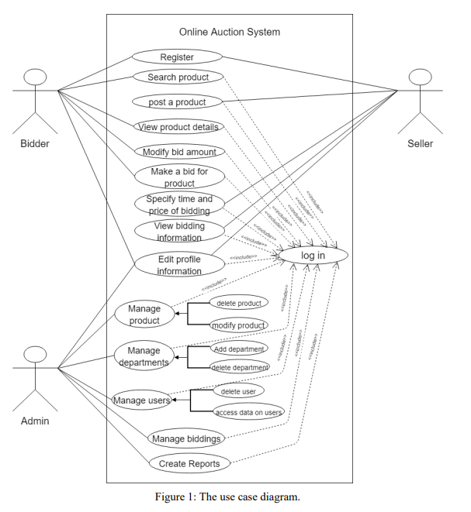

**Actor description**

**Companies**: the one who lists items for auction on the platform. They can set the starting price, duration of the auction, and any other relevant details about the item. They can also track bids and communicate with potential buyers.

**Buyers**: the one who browses the auction listings and places bids on items they are interested in. They can monitor auctions, adjust their bids, and track their success in winning items.

**Administrator:** The administrator is responsible for the overall management of the auction platform. They may handle tasks such as setting up the system, managing user accounts, ensuring fair play, and resolving disputes. They may also generate reports and analyze data to improve the platform.

**2.3.4.1 Essential Use Case Description**

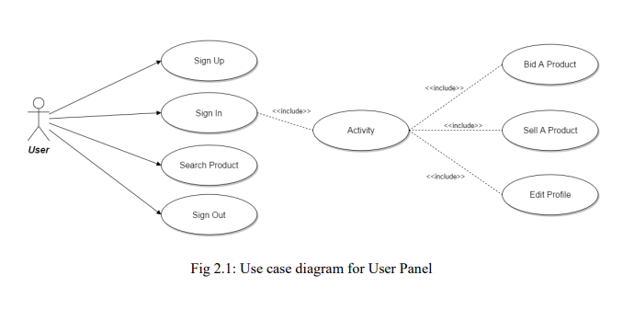

## **Use Case: Placing a Bid on an Auction Item**

This use case describes the scenario where a bidder finds an item they are interested in on the online auction platform and submits a bid.

**Actors:**

* Bidder: The user who wants to purchase an item through the auction.

**Preconditions:**

* The bidder has a registered account on the platform.
* The bidder is logged in to their account.
* An auction for the desired item is ongoing and accepting bids.

**Basic Flow:**

1. The bidder browses the available auctions through categories or search functionalities.
2. The bidder finds an item of interest and clicks on the auction listing to view details.
3. The auction details page displays information like item description, photos, current highest bid, reserve price (if any), and time remaining in the auction.
4. The bidder decides to place a bid. They enter a bid amount in the designated field.
5. The system validates the bid amount. It checks if the bid is higher than the current highest bid and meets the minimum bid increment (if applicable).
6. If the bid is valid, the system confirms the bid. The bidder receives a message indicating their bid has been placed successfully and they are now the highest bidder (if applicable).
7. The auction details page updates to reflect the new highest bid and the bidder's username (unless anonymous bidding is allowed).
8. The system may notify the previous highest bidder (if any) that they have been outbid.

**Alternative Flows:**

* **Invalid Bid:** If the bidder enters an invalid amount (e.g., lower than the current highest bid or minimum increment), the system displays an error message explaining the issue and prompts the bidder to enter a valid amount.
* **Reserve Not Met:** If the auction has a reserve price and the bidder's maximum bid is not high enough, the system may inform the bidder that the reserve has not been met without revealing the actual reserve price.
* **Outbid:** The bidder places a bid, but another bidder submits a higher bid before the auction closes. The system notifies the first bidder that they have been outbid.

**Post conditions:**

* The bidder has successfully placed a bid on the chosen item, and they become the highest bidder if their bid is the current highest.
* The auction details page reflects the updated bid information.
* Depending on the scenario, other users involved (previous highest bidder, seller) may receive notifications.

**Use Case Diagram for Administrative panel**

Use case diagram for administration panel is given in the following figure 2.2

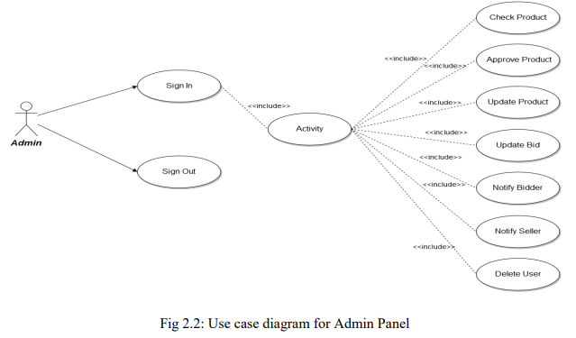

Functionalities provided:

* Check Product: Admin can check products
* Approve Product: Admin can approve products
* Update product: Admin can update products
* Update Bid: Admin can update bid status
* Notify: Admin can notify bidders and sellers
* Delete user: Admin can delete user

**2.3.4.2 Sequence Diagram**

A sequence diagram is one of the UML dynamic models, and it defines the interaction scene between the objects in time when the use case was executed and highlights the information sending time priority among objects. Usually, the sequence diagram illustrates the single use-case behavior.

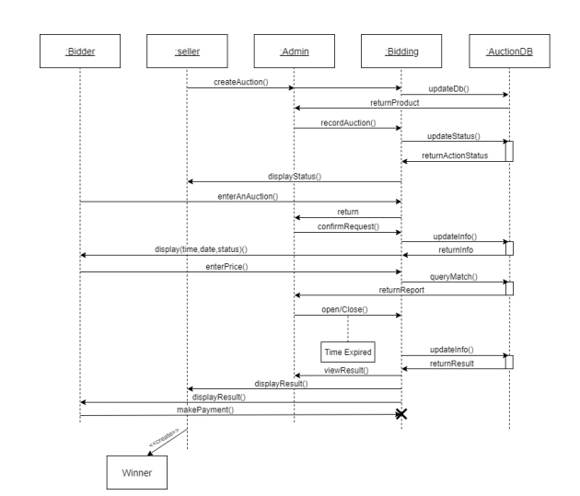

* + - 1. **Activity diagram**

**Activity Diagram for User panel**

Activity diagram for user panel is given in the following figure 2.3

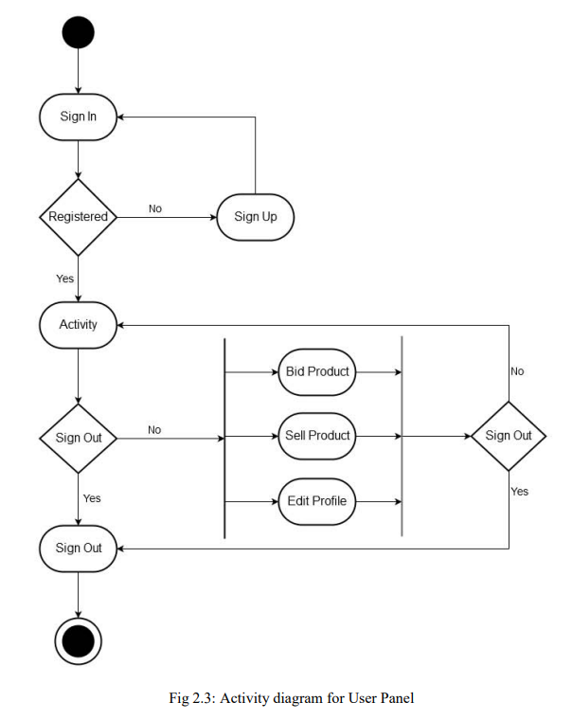

**Activity Diagram for Admin panel**

Activity diagram for admin panel is given in the following figure 2.4

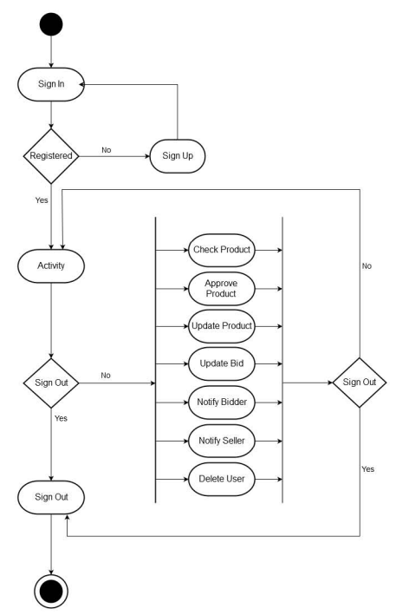

* + - 1. **Class diagram**

In Object-Oriented analysis and design, the class diagram is the most essential entity. It defines the kinds of objects that are present in the system and describes the static relationships between the system internal classes. The operations and attributes of a class and the constraints that apply to the objects connection can be shown by the class diagram.

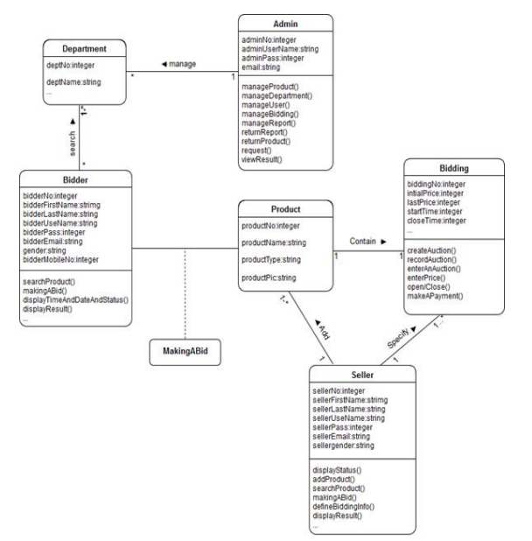

**3. System Design**

3.1 **Introduction**

System design is the process of defining and planning the architecture ,components, modules , interfaces, and interactions of complex software. It involves making decisions about how different parts of the system will work together to achieve the desired functionality, performance, scalability, reliability and maintainability.

The goal of system design is to create a blueprint or road map for building a system that meets the requirements and objectives of a project. This includes breaking down system into smaller subsystems, modules or components and determining how they will communicate and collaborate to accomplish the overall goals.

3.2 **Purpose of the System**

Online auction software serves as an advanced platform enabling the seamless exchange of goods and services through virtual auctions. This tech-powered solution boasts a plethora of features, catering to the needs of both auction sellers and bidders. It mirrors the dynamics of traditional in-person auctions while leveraging the benefits exclusive to the digital landscape.

### **Registration and User Accounts:** The journey usually commences with users signing up on the build an auction website. This involves furnishing vital details like name, contact information, and payment particulars. Post-registration, users gain entry to a plethora of functionalities inherent to an Auction website online, empowering them to engage in auctions and oversee their bidding endeavors effectively.

### **Auction Listings**: Auctioneers or sellers utilize the build an auction website to list their items or services. They upload images, descriptions, and establish starting prices, reserve prices (if applicable), and the duration of the auction. This data is then accessible to potential bidders browsing through the Auction website online, enabling them to discover items of interest.

### **Bidding Interface:** A fundamental component of build an auction website is its bidding interface. Users engage with this interface to place bids on items they desire, with the software automatically updating the highest bid in real-time. Within this process on the Auction website online, users can utilize features like “automatic bidding” or “proxy bidding.” These functionalities enable users to set a maximum bid amount, which the system then utilizes to incrementally raise their bid as competing bids are placed. Such features heighten the excitement of the auction experience, allowing bidders to outbid each other seamlessly without the need for constant monitoring.

### **Auction Countdown:** Auctions hosted on build an auction website have a predetermined duration, usually spanning from several hours to a few days. Throughout this period, bidders on the Auction website online engage in competition by submitting their bids. The online auction software incorporates a countdown timer, prominently displaying the remaining time until the auction’s conclusion. Once the timer reaches zero, signaling the end of the auction, the highest bidder emerges victorious and secures the item.

### **Payment Processing:** Following the closure of an auction to build an auction website, the winning bidder is required to finalize the transaction. Auction websites online commonly integrates with payment gateways, enabling users to securely make payments for their successful bids. Auctioneers receive their payments promptly, while buyers can make arrangements for the pickup or delivery of their purchased items.

* 1. **Design goals**

* 1. **Current software architecture**
  2. **Proposed software architecture**
     1. **Subsystem decomposition**

Subsystem decomposition is a process commonly used in systems engineering and software development to break down a complex system into smaller, more manageable subsystems. The aim is to simplify the overall system design and development process by dividing it into smaller, more specialized components that can be designed, implemented, tested, and maintained independently.

Here are our subsystem:

**3.8.1.1 login subsystem**

The login subsystem is a critical component of many software systems, especially those that require user authentication and authorization. Its primary responsibility is to manage user access to the system by verifying the identity of users and granting them appropriate permissions based on their credentials.

Here are our online auction login subsystem key function

**User Authentication:** The login subsystem authenticates users by verifying their credentials, usually a combination of a username/email and a password. It ensures that only authorized users can access the system.

**Credential Verification:** Upon receiving user credentials, the subsystem checks whether they match the stored credentials in the system's database. This process may involve hashing and comparing passwords for security.

**Session Management:** After successful authentication, the subsystem creates and manages a session for the user. This session often includes information such as the user's identity, authentication status, and possibly other relevant data.

**Security Measures:** The subsystem implements security measures to protect user credentials and sensitive information during transmission and storage. This often includes encryption, secure protocols (e.g., HTTPS), and best practices for password management.

**3.8.1.2 Sign up subsystem**

The sign up subsystem, also known as the registration subsystem, is responsible for facilitating the process through which users create new accounts with in a software system. Its primary goal is to collect necessary information from users, validate it, and then create a new user account with in the system.

Here are our online auction sign up subsystem key function

**User Input Validation:** The subsystem validates the information provided by the user during the sign up process. This includes verifying that all required fields are filled out, checking the format of email addresses and other input data, and ensuring that passwords meet security requirements (e.g., minimum length, complexity).

**Duplicate Checking:** Before creating a new user account, the subsystem checks for duplicates to prevent multiple accounts with the same information. This may involve verifying that the chosen username or email address is not already in use within the system.

**Authentication and Authorization**: The sign up subsystem integrate with authentication and authorization mechanisms will verify the identity of users during the sign up process. This includes email verification or SMS verification.

**Account Creation:** Once all required information is validated and duplicate checks are passed, the subsystem creates a new user account in the system. This involves storing user information in a database assigning a unique identifier and setting up initial account settings (e.g default preferences).

**Security Measures:** The sign up subsystem implements security measures to protect user information and prevent misuse. This includes encryption of sensitive data during transmission and storage, protection against automated bot attacks (e.g. CAPTCHA), and adherence to best practices for secure account creation

**3.8.1.3 Payment Processing Subsystem**

The payment subsystem is a crucial component of many platforms and other systems that involve financial transactions. Its primary responsibility is to facilitate the secure and efficient processing of payments between buyers and sellers or between users and the system itself.

Here are our online auction Payment Processing Subsystem key function

**Payment Gateway Integration:** The payment subsystem integrates with one or more payment gateways, which are third-party services that handle the processing of financial transactions. These gateways facilitate communication between the system and the third party API that we will be using Telebirr and chapa.

**Transaction Processing:** Upon receiving payment requests from users, the payment subsystem processes these transactions securely and efficiently. Since we will be using third API the transaction process goes through them and we will be verifying if the process is handled correctly.

**Transaction Logging and Reporting:** The payment subsystem logs all payment transactions and related activities for auditing, reconciliation, and reporting purposes. This includes recording transaction details such as timestamps, amounts, payment methods, and transaction IDs, as well as generating reports for financial analysis and accounting purposes.

**Error Handling and Recovery:** In case of payment failures, errors, or exceptions from API, the subsystem implements robust error handling mechanisms to gracefully handle such situations. This may involve retrying failed transactions, providing informative error messages to users, and notifying administrators or support personnel for further investigation and resolution.

**3.8.1.4 Biding Subsystem**

The bidding subsystem is a central component of online auction systems, facilitating the process by which users place bids on items and compete to win auctions. Its primary purpose is to manage the bidding process securely, fairly, and efficiently, ensuring that users can participate in auctions and make bids in accordance with the auction rules.

Here are our online auction Biding Subsystem key function

**Item Listing:** Sellers list items for auction on the platform. This includes details such as item description, starting price, minimum bid increment, auction duration, and any other relevant information.

**Bid Placement:** Registered users can place bids on items listed in the online auction system. The subsystem accepts bid submissions from users, verifies their eligibility to participate in the online auction, and records their bids along with relevant information such as bid amount, bidder identity, and timestamp.

**Bid Validation:** Before accepting a bid, the subsystem validates it to ensure that it meets the online auction system rules and requirements. This includes checking that the bid amount is higher than the current highest bid (if any) and adheres to the specified bid increment rules.

**Real-time Bid Updates:** The subsystem provides real-time updates to users regarding the current highest bid for each item and any changes in bidding status. This ensures that users have up-to-date information about the auction's progress and can adjust their bidding strategies accordingly.

**Bid History**: The subsystem maintains a complete history of all bids placed on each item, including the bid amounts, bidder identities, timestamps, and bid statuses. This audit trail provides transparency and accountability, allowing users to review past bidding activities and verify the integrity of the online auction process.

**3.8.1.5 Auctioning Subsystem**

The Auction subsystem is the core component of an online auction system, responsible for managing the entire life cycle of auctions, from creation to completion. It provides the platform for sellers to list items for auction and for buyers to place bids on those items.

Here are our online auction auctioning subsystem key function

**Item Listing:** Sellers list items for auction on the platform. This includes details such as item description, starting price, minimum bid increment, auction duration, and any other relevant information.

**Auction Creation:** The subsystem facilitates the creation of auctions based on seller listings. It manages the scheduling, duration, and visibility of auctions, ensuring they adhere to predefined rules and policies.

* + 1. **Component diagram**
    2. **Deployment diagram**
    3. **Persistent data management**

Persistent data management describes the persistent data stored by the system and the data management infrastructure required for it.

* + 1. **Access control and security**

Access control and security describes the user model of the system. Access control is a security measure that determine who is allowed to access to access a system, application, database or other resource in the system and what actions they are permitted to perform once they have gained access

To ensure access control and security for our system we will implement:

**1. User Authentication:** a robust user authentication system such multi-factor authentication to verify the identity user before granting access for them to auction and bid.

**2. Role Based Access Control:** Assigning different roles to the users and restricting their access based on their role. This will help in controlling what actions different users can perform within the system.

**3. Secure Communication:** Using https to encrypt data transmitted b/n the user’s browser and the server to protect any tampering in the biding process

**4. Data Encryption:** Encrypting sensitive data such as user credential, payment information and auction details to prevent unauthorized access in case of data breach.

**5. Input Validation:** Strict input validation to prevent common security vulnerabilities such as SQL Injection, cross-site scripting(XSS) and cross-site request forgery(CSRF)

**6. Secure Payment Processing:** ensuring the system complies with industry standard security.

**7. Regular Security Audits:** Conducting regular security audits and vulnerability assessments to identify and address any potential security weakness in web app. And providing bug bounty programs.

**8. Session Management:** Use Secure session management to prevent session hijacking and ensure that user sessions are securely managed.

* + 1. **Global software control**

Global software control refers to the mechanisms and strategies implemented to manage and coordinate the overall operation and behavior of a software system. In the context of an online auction web system, global software control ensures that all components of the system work together seamlessly, maintaining consistent performance, reliability, and security across the entire application.

Here are the key aspects of global software control for our online auction system

**1. Coordination and Scheduling**

Global software control involves managing the coordination and scheduling of various system activities. This includes:

**Auction Timings**: Ensuring that auctions start and end at the scheduled times.

**Bid Processing**: Coordinating the reception and processing of bids in real-time.

**Notifications:** Scheduling notifications for users about auction events (e.g bid status, auction

**2. Error Handling and Recovery**

Implementing strategies to handle errors and recover from failures:

**Error Detection:** Identifying and logging errors that occur during system operation.

**Fault Tolerance**: Ensuring that the system can continue functioning even in the presence of certain faults (e.g using redundant servers or fail over mechanisms).

**Recovery Mechanisms**: Procedures for recovering from failures, such as restoring from backups or reprocessing failed transactions.

**3. Configuration Management**

Managing the configuration of system components to ensure consistency and proper operation:

**Configuration Files**: Keeping track of configuration files and settings for various components.

**Version Control**: Using version control systems to manage changes to the system's code base and configurations. By using github.

**4. System Integration**

Ensuring smooth integration and interaction with external systems and services:

**Application Program Interfaces(APIs)**: Managing the use of APIs for communication with third-party services (e.g Telebirr, chapa).

**Data Synchronization**: Ensuring data consistency and synchronization between the auction system and external systems.

**5. Software Updates and Maintenance**

Planning and executing software updates and maintenance tasks to ensure the system remains up-to-date and functional:

**Patch Management:** Applying security patches and updates to keep the system secure.

**Feature Updates:** Rolling out new features and improvements without disrupting the existing functionality

* + 1. **Boundary conditions**

Boundary Conditions refers to the scenarios o conditions at the extreme ends of input spectrum that a system or component must handle correctly. These conditions test the limits of the system’s functionality to ensure it can handle edge cases without failure. Boundary conditions are crucial for identifying bugs and ensuring robustness.

For our online auction web system we will be implementing the following cases:

**1. Minimum and Maximum Values**

We will be testing with the smallest and highest possible bids that will be accepted on the system and the limitations on it.

**2. Just Inside/Outside Boundary**

We will be testing the valid input bid ranges from the starting price and just out side the valid bid ranges

**3. Empty And Null Values**

Handling cases where bids might be empty, the name product is probably filed, price also is also not empty

**4. Special Values**

Handling cases where input might contain special numeric values like zero,negative numbers and Not a number (NaN)

**5. Login System**

Ensuring the minimum and maximum password lengths. Handling invalid characters in username and password

**6. Date and time**

Ensuring the system handles or contains the earliest and latest possible bid date and time in the system and leap year handling